

ISO 9001:2008 Certified Institute

# JAVA INSTITUTE FOR ADVANCED TECHNOLOGY

Department of Examinations

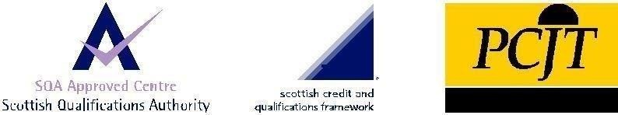

|  |  |
| --- | --- |
| COURSE(S) – (LEADING TO) | PROFESSIONAL HIGHER DIPLOMA IN SOFTWARE ENGINEERING |
| ASSIGNMENT STARTING DATE | 05th May 2020 |
| ASSIGNMENT CLOSING DATE | 12th May 2020 |
| UNIT NAME | SOFTWARE ENGINEERING II (SOFTWARE TESTING, QUALITY ASSURANCE AND MAINTENANCE) |
| UNIT ID | HF2W 04 |
| ASSIGNMENT ID | HF2W 04/AS/06 |
| DESCRIPTION | SQA concept (Individual Assignment) |
| DURATION | 1 Day |

**GUIDE LINES FOR CANDIDATES**

Students should describe step by step testing process which has specific steps to be executed in a definite sequence to ensure that the quality goals have been met. And student will understand each activity is carried out in a planned and systematic way.

|  |  |
| --- | --- |
| NAME : | KANDAGE DON ISHAN VIHANGA VIMUKTHI  .................................................................................................................................... (BLOCK CAPITALS) |
| NIC : | 960263812v  .................................................................................................................................... |
| SCN NO : | 177646148  .................................................................................................................................... |

Java Institute for Advanced Technology Sri Lanka

# TEST SUPPORT TOOL

1. What are the categories of defects? [10 marks]

**Minor defects**

Minor defects are usually small, insignificant issues that don’t affect the function or form of the item. In most cases, the customer wouldn’t even notice a minor defect on a product. And the customer wouldn’t likely return an item due to a minor defect alone.

**Major defects**

Major defects are more serious than minor defects. A product withquality defects a major defect departs significantly from the buyer’s product specifications. Major defects are those which could adversely affect the function, performance or appearance of a product.

These defects are readily noticeable by the customer. And these defects would likely cause a customer to return the product, lodge a complaint or request a refund in response.

Most importers set a lower limit for major defects than minor defects in their inspected sample size. They’ll often accept an order with relatively few major defects. But they’re likely to reject an order, or ask their supplier to hold or rework it, if the goods fail inspection due to an excessive number of major defects found.

**Critical defects**

Critical defects are the most serious of the three defect types. Critical defects render an item completely unusable and/or could cause harm to the user or someone in the vicinity of the product.

These defects put businesses at serious risk of product liability issues, lawsuits and product recalls.

Many importers have a “zero tolerance” policy for critical defects in their orders commensurate with this risk. An item will often fail product inspection if a single critical defect is found within the order.

Importers often set the highest tolerance—or AQL, if applying that standard—for minor defects in their inspected sample size. But an item can still fail inspection if the number of minor defects found exceeds the limit set by their tolerance

1. What is the difference between a defect and a failure?[10 marks]

|  |  |
| --- | --- |
| Defect | Failure |
| A mistake that falls short of your plans for a product or service | A defect that reaches a customer |

1. Are there more defects in the design phase or in the coding phase?[10 marks]

The design phase is more error prone than the execution phase. One of the most frequent defects which occur during design is that the product does not cover the complete requirements of the customer. Second is wrong or bad architecture and technical decisions make the next phase, execution, more prone to defects. Because the design phase drives the execution phase it's the most critical phase to test. The testing of the design phase can be done by good review. On average, 60% of defects occur during design and 40% during the execution phase.

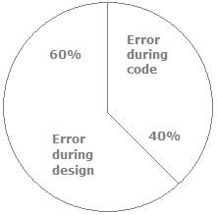

1. What is a test log?[05marks]

The IEEE Std. 829-1998 defines a test log as a chronological record of relevant details about the execution of test cases. It's a detailed view of activity and events given in chronological manner.

The following figure shows a test log and is followed by a sample test log.

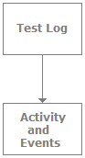

1. Can you explain requirement traceability and its importance?[05 marks]

In most organizations testing only starts after the execution/coding phase of the project. But if the organization wants to really benefit from testing, then testers should get involved right from the requirement phase.

If the tester gets involved right from the requirement phase then requirement traceability is one of the important reports that can detail what kind of test coverage the test cases have.

1. A defect which could have been removed during the initial stage is removed in a later stage. How does this affect cost?[10marks]

If a defect is known at the initial stage then it should be removed during that stage/phase itself rather than at some later stage. It's a recorded fact that if a defect is delayed for later phases it proves more costly. The following figure shows how a defect is costly as the phases move forward. A defect if identified and removed during the requirement and design phase is the most cost effective, while a defect removed during maintenance is 20 times costlier than during the requirement and design phases.

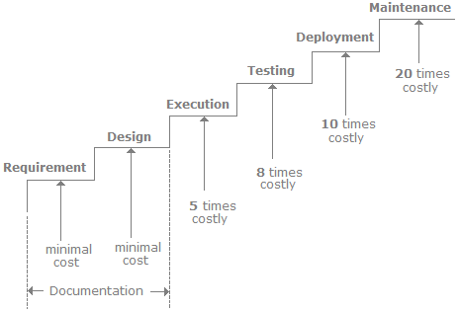

For instance, if a defect is identified during requirement and design we only need to change the documentation, but if identified during the maintenance phase we not only need to fix the defect, but also change our test plans, do regression testing, and change all documentation. This is why a defect should be identified/removed in earlier phases and the testing department should be involved right from the requirement phase and not after the execution phase.

1. What kind of input do we need from the end user to begin proper testing?[15 marks]

The product has to be used by the user. He is the most important person as he has more interest than anyone else in the project.

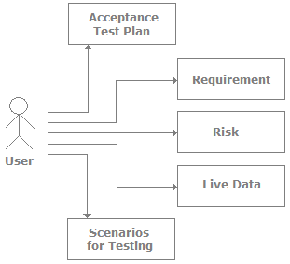

From the user we need the following data:

* The first thing we need is the acceptance test plan from the end user. The acceptance test defines the entire test which the product has to pass so that it can go into production.
* We also need the requirement document from the customer. In normal scenarios the customer never writes a formal document until he is really sure of his requirements. But at some point the customer should sign saying yes this is what he wants.
* The customer should also define the risky sections of the project. For instance, in a normal accounting project if a voucher entry screen does not work that will stop the accounting functionality completely. But if reports are not derived the accounting department can use it for some time. The customer is the right person to say which section will affect him the most. With this feedback the testers can prepare a proper test plan for those areas and test it thoroughly.
* The customer should also provide proper data for testing. Feeding proper data during testing is very important. In many scenarios testers key in wrong data and expect results which are of no interest to the customer.

1. Can you explain decision tables with an example ?[15 marks]

Decision table testing is a software testing technique used to test system behavior for different input combinations. This is a systematic approach where the different input combinations and their corresponding system behavior (Output) are captured in a tabular form. That is why it is also called as a **Cause-Effect** table where Cause and effects are captured for better test coverage.

A Decision Table is a tabular representation of inputs versus rules/cases/test conditions. Let's learn with an example.

## Example 1: How to make Decision Base Table for Login Screen

Let's create a decision table for a login screen.

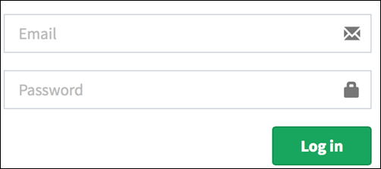

The condition is simple if the user provides correct username and password the user will be redirected to the homepage. If any of the input is wrong, an error message will be displayed.

|  |  |  |  |  |
| --- | --- | --- | --- | --- |
| **Conditions** | **Rule 1** | **Rule 2** | **Rule 3** | **Rule 4** |
| **Username (T/F)** | F | T | F | T |
| **Password (T/F)** | F | F | T | T |
| **Output (E/H)** | E | E | E | H |

Legend:

* T – Correct username/password
* F – Wrong username/password
* E – Error message is displayed
* H – Home screen is displayed

Interpretation:

* Case 1 – Username and password both were wrong. The user is shown an error message.
* Case 2 – Username was correct, but the password was wrong. The user is shown an error message.
* Case 3 – Username was wrong, but the password was correct. The user is shown an error message.
* Case 4 – Username and password both were correct, and the user navigated to homepage

While converting this to test case, we can create 2 scenarios ,

* Enter correct username and correct password and click on login, and the expected result will be the user should be navigated to homepage

And one from the below scenario

* Enter wrong username and wrong password and click on login, and the expected result will be the user should get an error message
* Enter correct username and wrong password and click on login, and the expected result will be the user should get an error message
* Enter wrong username and correct password and click on login, and the expected result will be the user should get an error message

As they essentially test the same rule.

1. What is Automated Testing? [10 marks]

Automated testing is a process that validates if software is functioning appropriately and meeting requirements before it is released into production. This software testing method uses scripted sequences that are executed by testing tools. Automated testing tools execute examinations of the software, report outcomes and compare results with earlier test runs.

1. What is the difference between Testing Techniques and Testing Tools?[10 marks]

Techniques and tools are 2 different things. One mean the way you will do things, the other, the objects (tools) that you are going to do this things, although some testing tools are implemented to facilitate the implementation of some testing techniques.

I’ve experienced both situations: companies that wanted to follow a test technique and goes to the market looking for tools that support their test technique and companies that do not have any test technique in place and go for the market looking for testing tool that have some test technique in place so they start to build up their test team following the test tool.

# SQA CONCEPT

1. When to start QA in a project?[10 marks]\

A good time to start the QA is from the beginning of the project startup. This will lead to plan the process which will make sure that product coming out meets the customer quality expectation. QA also plays a major role in the communication between teams. It gives time to step up the testing environment. The testing phase starts after the test plans are written, reviewed and approved.

1. What is difference between Smoke testing and Sanity Testing?[10 marks]

|  |  |
| --- | --- |
| **Smoke Testing** | **Sanity Testing** |
| Smoke Testing is performed to ascertain that the critical functionalities of the program is working fine | Sanity Testing is done to check the new functionality/bugs have been fixed |
| The objective of this testing is to verify the "stability" of the system in order to proceed with more rigorous testing | The objective of the testing is to verify the "rationality" of the system in order to proceed with more rigorous testing |
| This testing is performed by the developers or testers | Sanity testing is usually performed by testers |
| Smoke testing is usually documented or scripted | Sanity testing is usually not documented and is unscripted |
| Smoke testing is a subset of Acceptance testing | Sanity testing is a subset of Regression Testing |
| Smoke testing exercises the entire system from end to end | Sanity testing exercises only the particular component of the entire system |
| Smoke testing is like General Health Check Up | Sanity Testing is like specialized health check up |

1. What is Test ware ?[10 marks]

Artifacts produced during the test process required to plan, design, and execute tests, such as documentation, scripts, inputs, expected results, set-up and clear-up procedures, files, d bases, environment, and any additional software or utilities used in testing

1. Explain bug life cycle.[15 marks]

Bug Life Cycle is the specific set of states that a Bug goes through in its entire life. The purpose of the Defect life cycle is to easily coordinate bug status changes to various assignees and make the bug fixing process systematic.

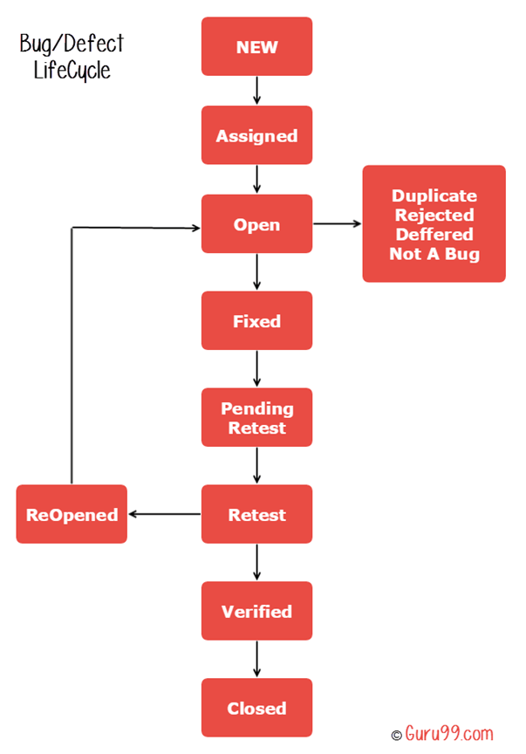

New: When a new defect is logged and posted for the first time. It is assigned a status as NEW.

Assigned: Once the bug is posted by the tester, the lead of the tester approves the bug and assigns the bug to the developer team

Open: The developer starts analyzing and works on the defect fix

Fixed: When a developer makes a necessary code change and verifies the change, he or she can make bug status as "Fixed."

Pending retest: Once the defect is fixed the developer gives a particular code for retesting the code to the tester. Since the software testing remains pending from the testers end, the status assigned is "pending retest."

Retest: Tester does the retesting of the code at this stage to check whether the defect is fixed by the developer or not and changes the status to "Re-test."

Verified: The tester re-tests the bug after it got fixed by the developer. If there is no bug detected in the software, then the bug is fixed and the status assigned is "verified."

Reopen: If the bug persists even after the developer has fixed the bug, the tester changes the status to "reopened". Once again the bug goes through the life cycle.

Closed: If the bug is no longer exists then tester assigns the status "Closed."

Duplicate: If the defect is repeated twice or the defect corresponds to the same concept of the bug, the status is changed to "duplicate."

Rejected: If the developer feels the defect is not a genuine defect then it changes the defect to "rejected."

Deferred: If the present bug is not of a prime priority and if it is expected to get fixed in the next release, then status "Deferred" is assigned to such bugs

Not a bug:If it does not affect the functionality of the application then the status assigned to a bug is "Not a bug".

1. What is severity and priority of bug? Give some example.[05 marks]

**Severity**

Severity is defined as the degree of impact a Defect has on the development or operation of a component application being tested.

Higher effect on the system functionality will lead to the assignment of higher severity to the bug. Quality Assurance engineer usually determines the severity level of defect

**Priority**

Priority is defined as the order in which a defect should be fixed. Higher the priority the sooner the defect should be resolved.

Defects that leave the software system unusable are given higher priority over defects that cause a small functionality of the software to fail.

## Example of Defect Severity and Priority

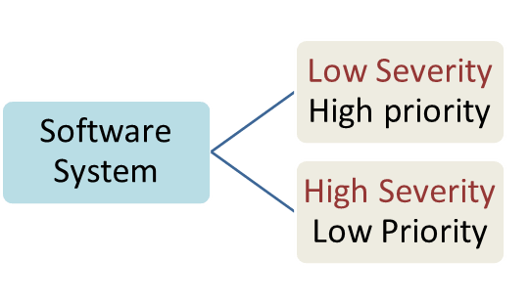

Let see an example of low severity and high priority and vice versa

• A very low severity with a high priority: A logo error for any shipment website, can be of low severity as it not going to affect the functionality of the website but can be of high priority as you don't want any further shipment to proceed with the wrong logo.

• A very high severity with a low priority: Likewise, for flight operating website, a defect in reservation functionality may be of high severity but can be a low priority as it can be scheduled to release in a next cycle.

1. What is the role of QA in a project development?[10 marks]

The quality assurance (QA) role is one that is focused on creating a quality deliverable. In other words, it is the responsibility of the QA role to make sure that the software development process doesn't sacrifice quality in the name of completed objectives.

The QA role works with the Functional Analyst (FA) and the Solutions Architect (SA) to convert the requirements and design documents into a set of testing cases and scripts, which can be used to verify that the system meets the client needs. This collection of test cases and scripts are collectively referred to as a test plan. The test plan document itself is often simple providing an overview of each of the test cases. The testing cases and scripts are also used to validate that there are no unexplained errors in the system.

1. What are the key challenges of software testing? [15 marks]

1. Testing considered late in project.

2. Requirements not testable.

3. Integration is done after all components have been developed: This might result into full testing not being covered.

4. Complete testing is not possible.

5. The application can be in a stable form so that it can be tested.

6. The testing always should be under time constraint.

7. There is lack of skilled testers.

8. The requirements may keep on changing.

9. There can be some lack of resources tools and training.

10. A complete application has to be tested.

11. A proper understanding of the requirements,domain knowledge and the business user perspective understanding.

12. To know which tests need to be execute first.

1. Explain bug leakage and bug release.[15 marks]

Bug Leakage: When customer or end user discovered a bug which can be detected by the testing team. Or when a bug is detected which can be detected in pervious build then this is called as Bug Leakage.

Bug release: is when a build is handed to testing team with knowing that defect is present in the release. The priority and severity of bug is low. It is done when customer want the application on the time. Customer can tolerate the bug in the released then the delay in getting the application and the cost involved in removing that bug. These bugs are mentioned in the Release Notes handed to client for the future improvement chances.

1. What is data driven testing?[05 marks]

DATA DRIVEN TESTING is a test automation framework that stores test data in a table or spreadsheet format. This allows automation engineers to have a single test script that can execute tests for all the test data in the table.

1. What is quality audit?[05 marks]

Quality audit is the process of systematic examination of a quality system carried out by an internal or external quality auditor or an audit team. It is an important part of an organization's quality management system and is a key element in the ISO quality system standard, ISO 9001.